**OAS**

**Online Auction System**

**Made Using: PHP, HTML, JavaScript, JQuery, SQL, Adobe XD.**

**Created By: Harshit Bagga**

**OPEN ENDED PROBLEM**

**AIM:-** **Open ended problem for Online Auction System.**

* **GUI:**

**Registration Page:**

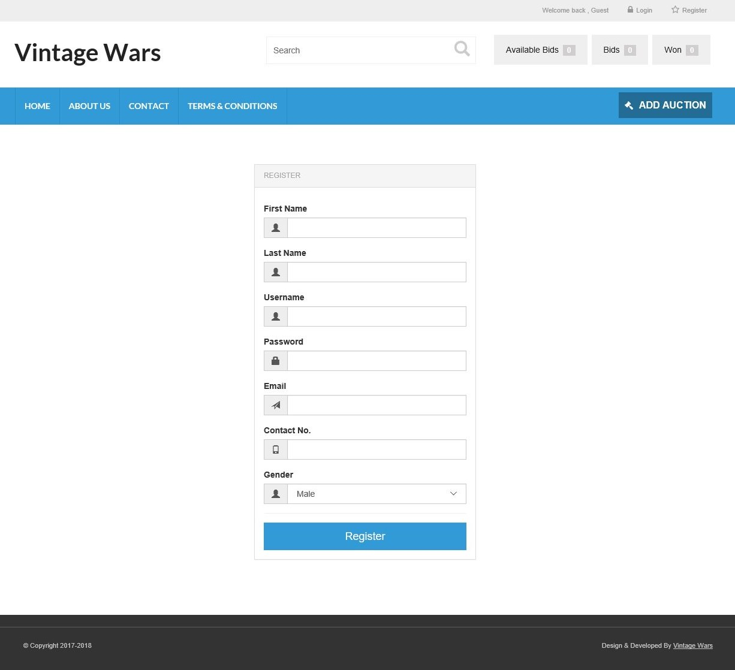

**Login Page:** 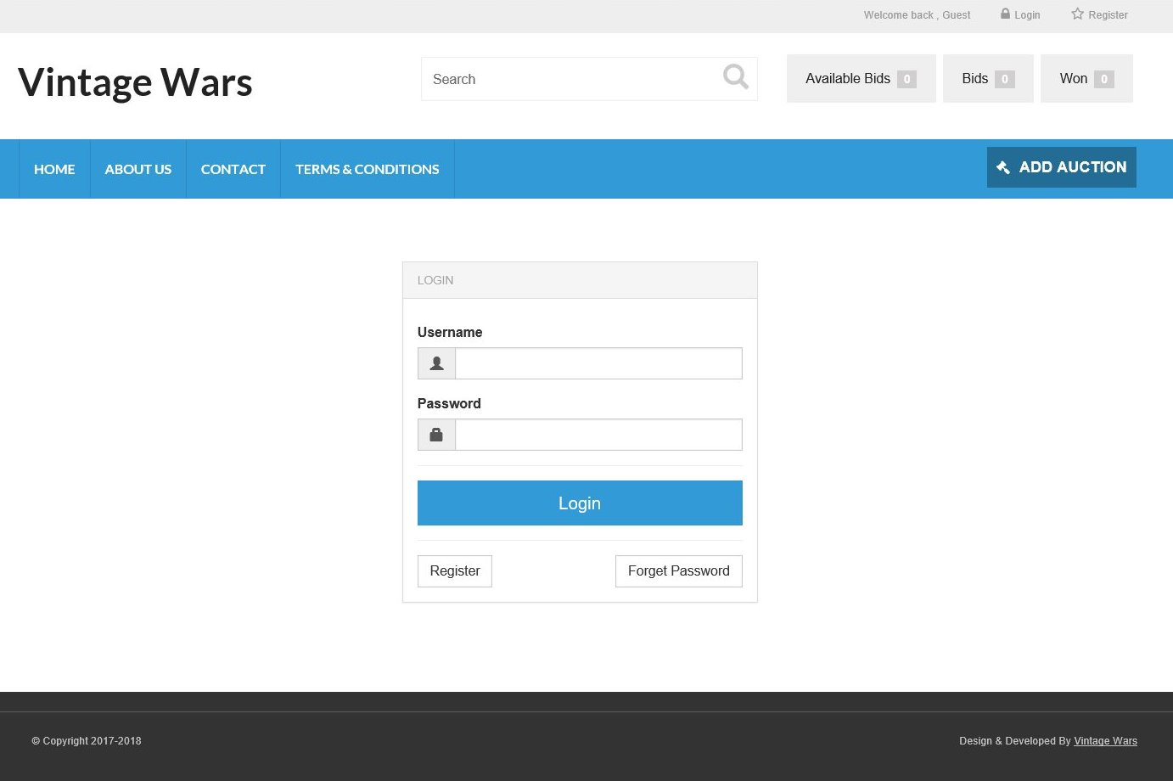

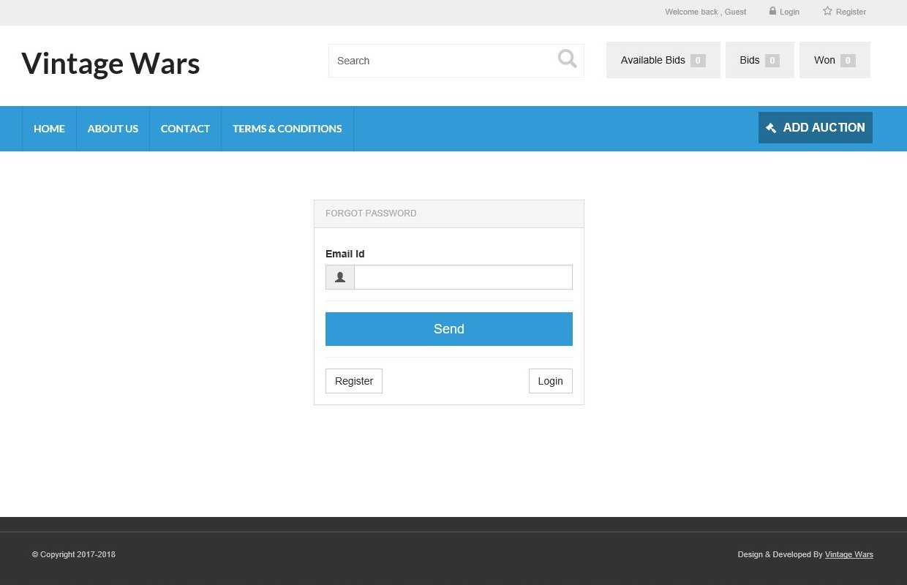

**Make Bid Auction:**

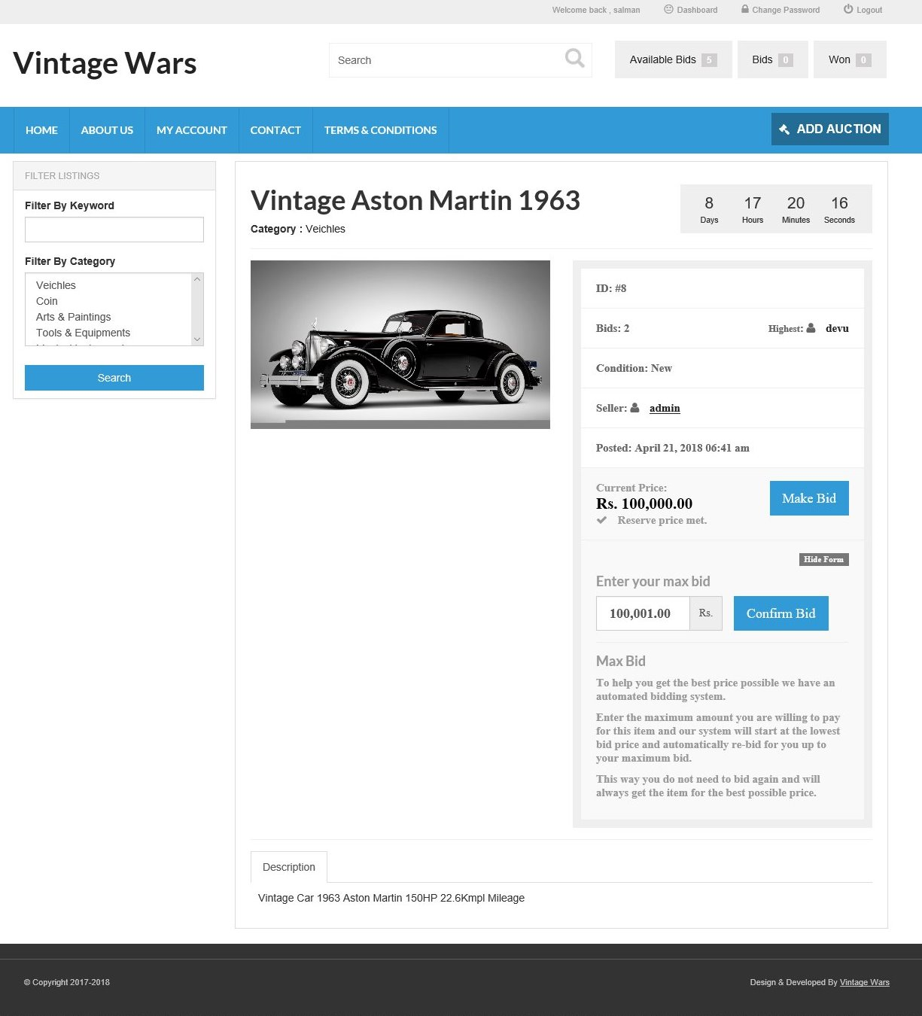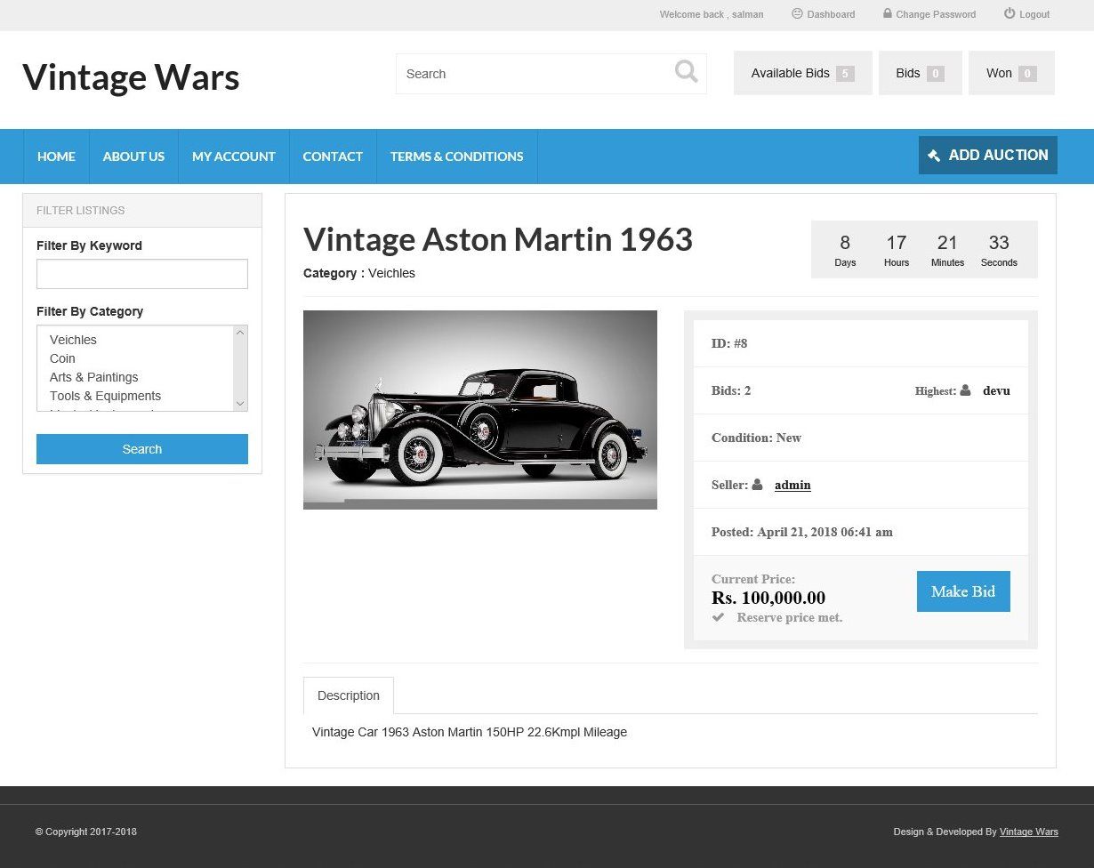

**My Account:**

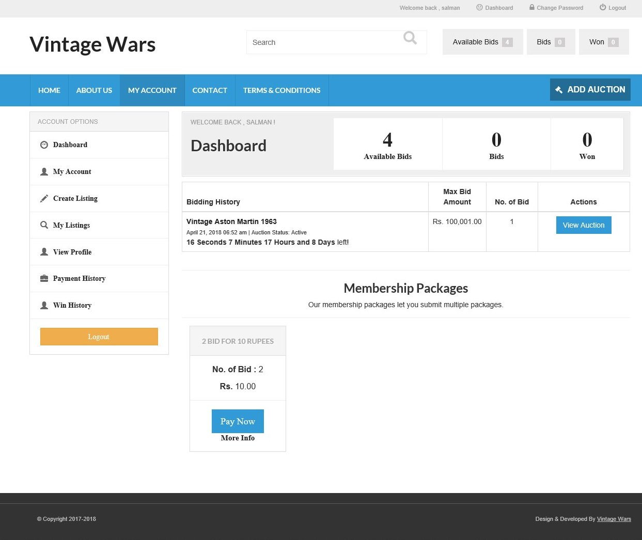

**My Account (My Account):**

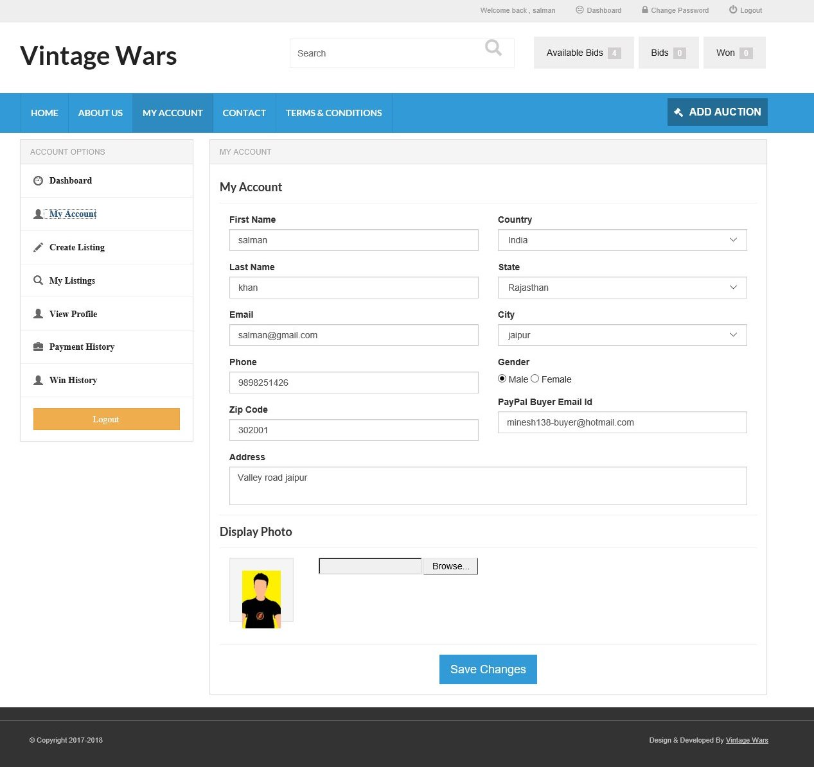

**My Account (Create Listing):**

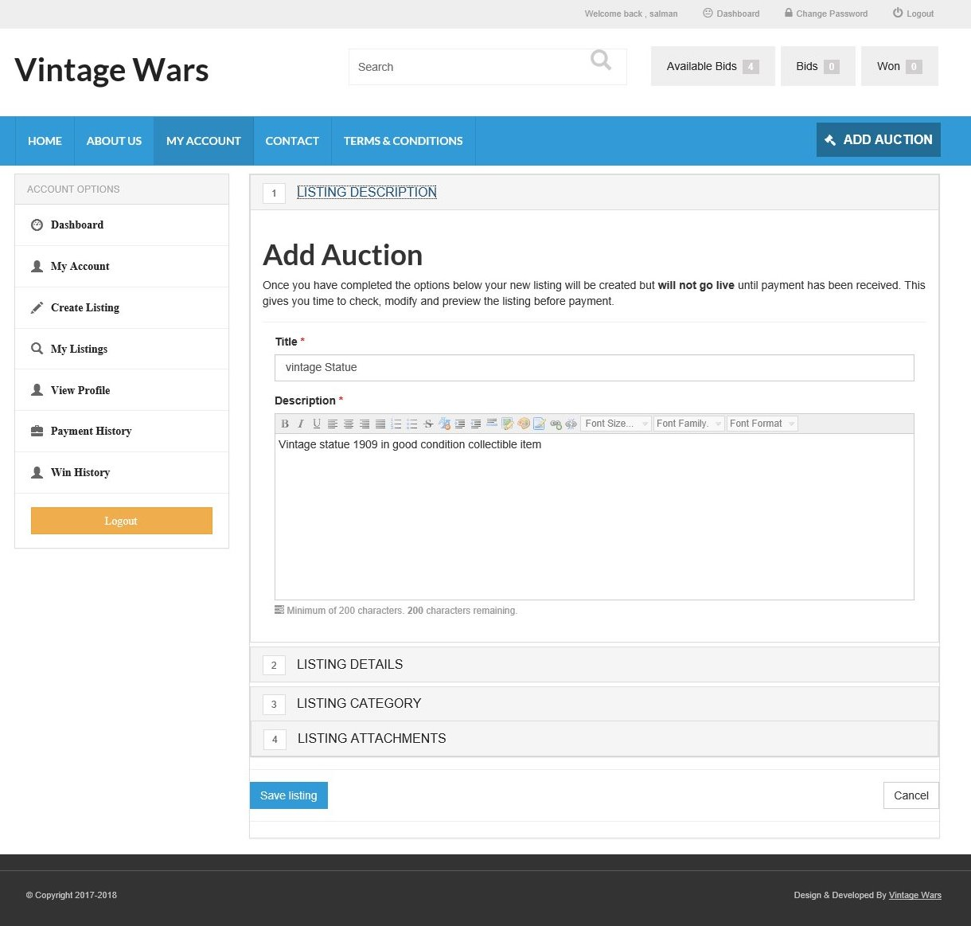**My Account (View Profile):**

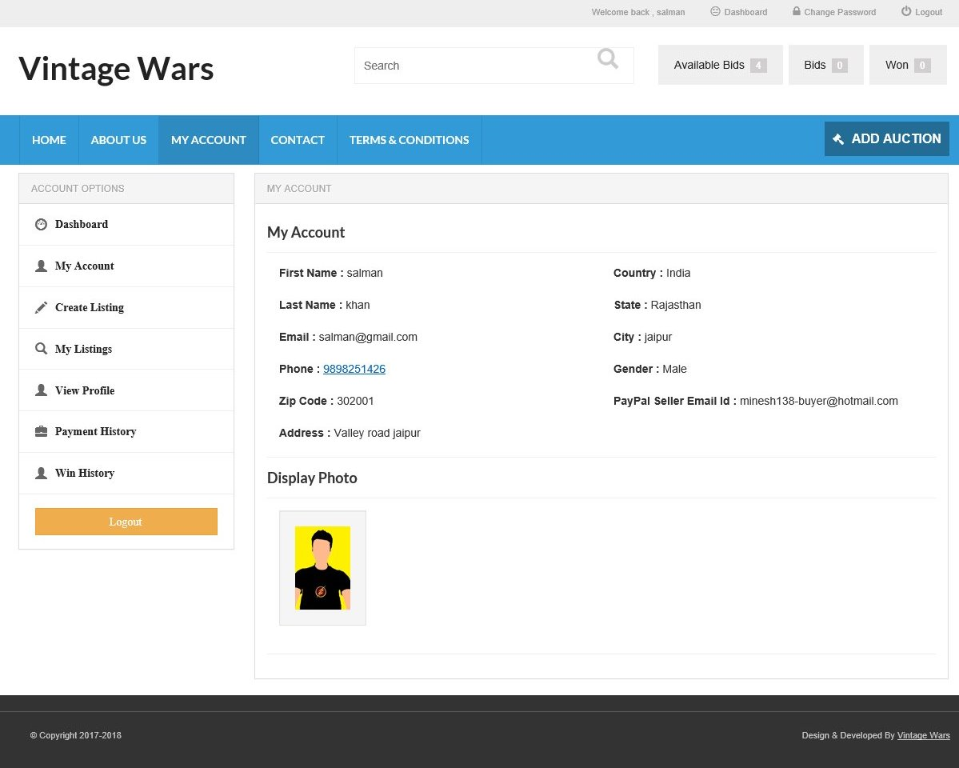

**My Account (Payment History):**

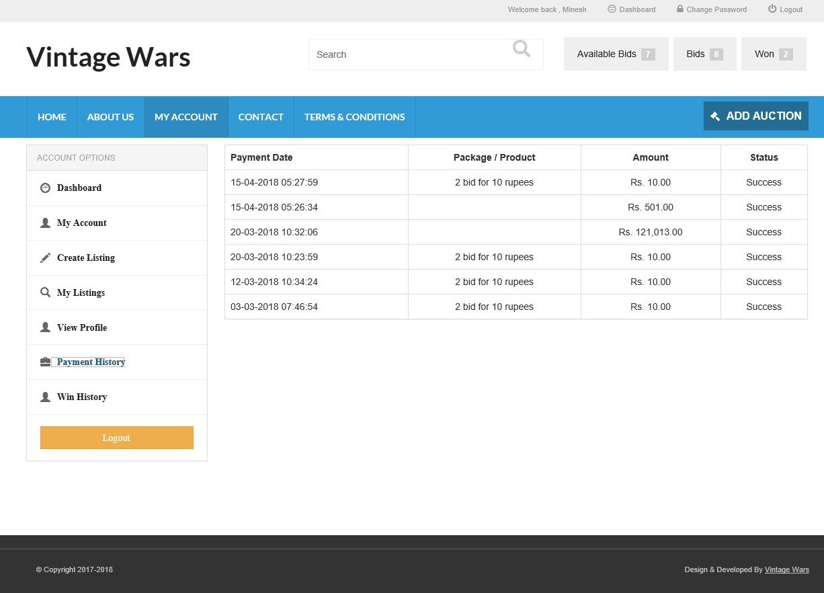

**My Account (Win History):**

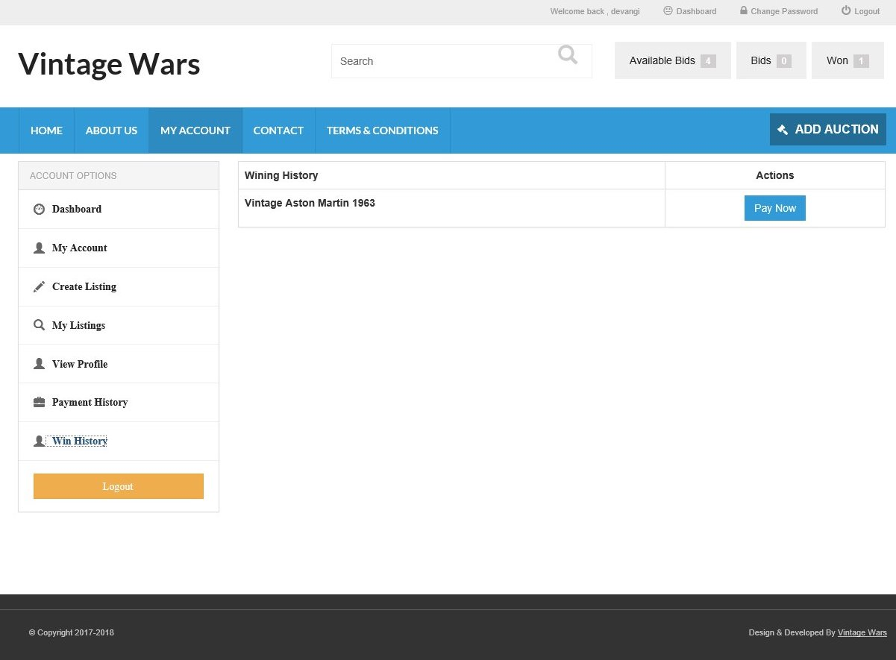

**Back-end:**

1. **User_Master:-**

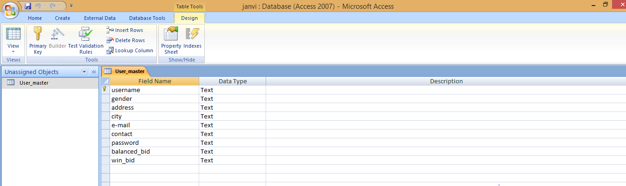**Table:**

**Field of Value:**

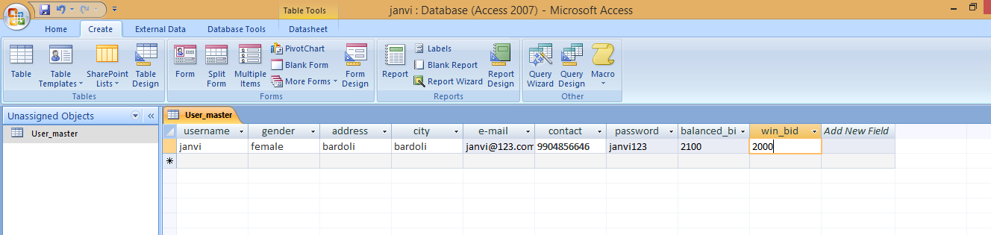

**Form:**

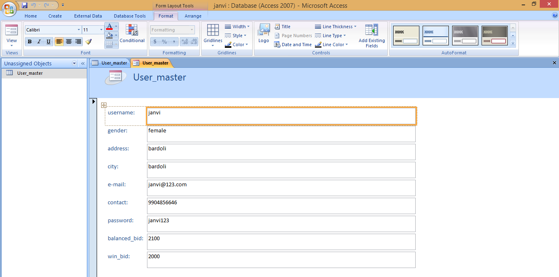

1. **Category_Master:-**

**Table:**

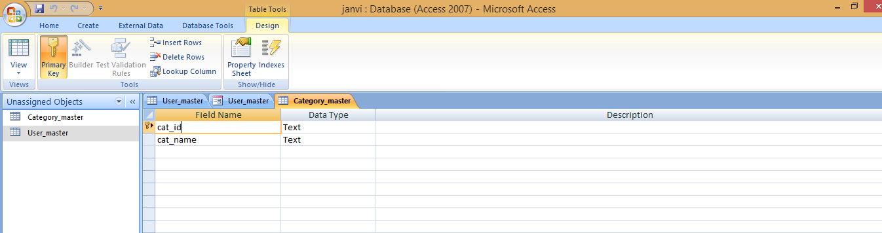

**Field of Value:**

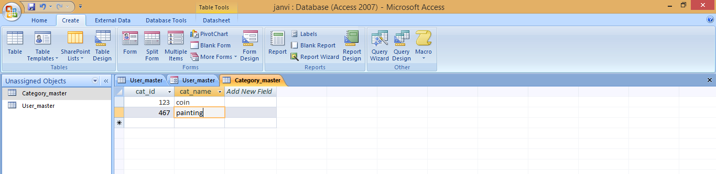

**Form:**

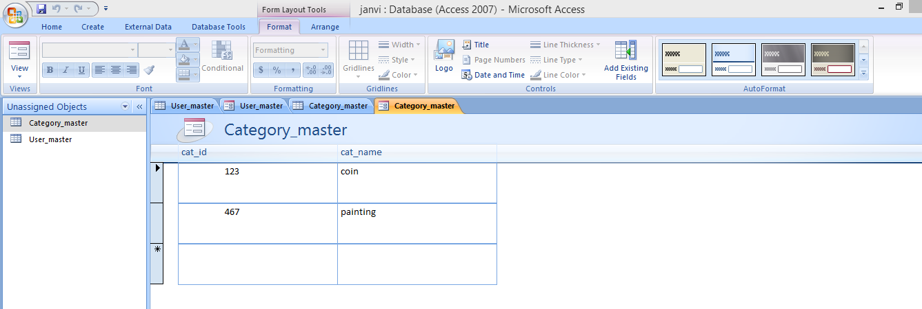

1. **City_Master:-**

**Table:**

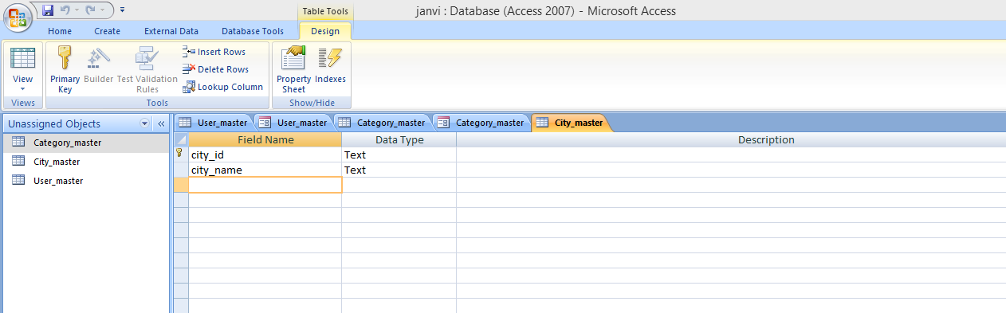

**Field of Value:**

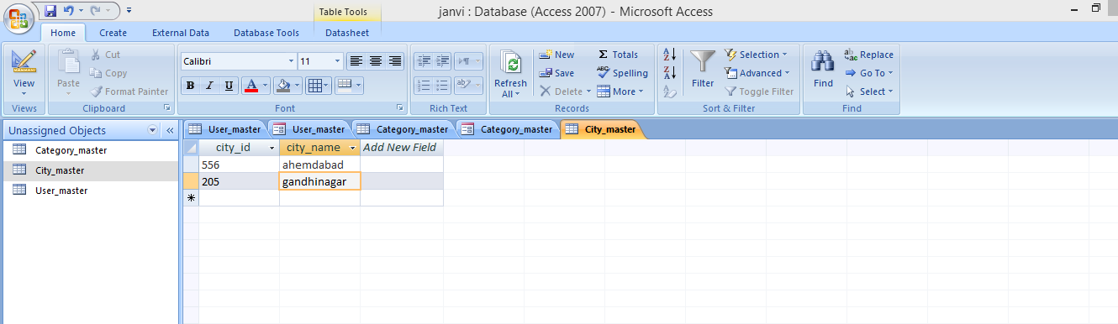

**Form:**

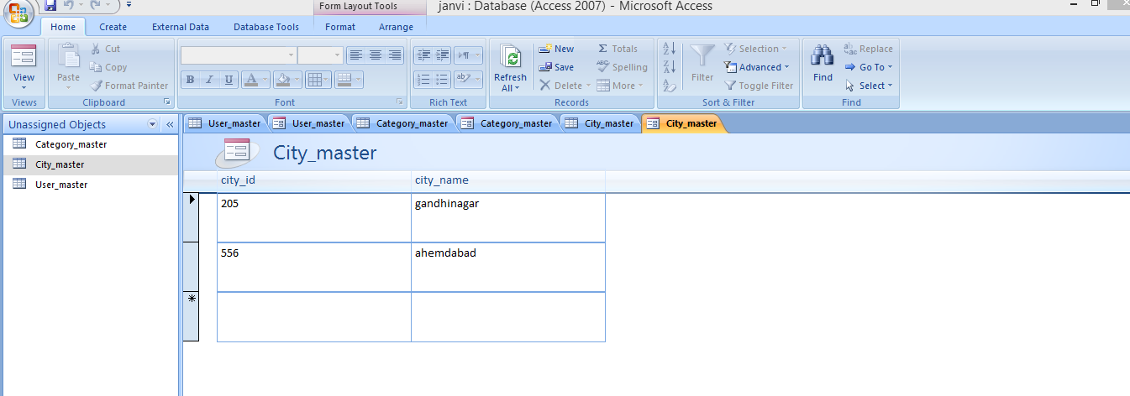

1. **Product_Master:-**

**Table:**

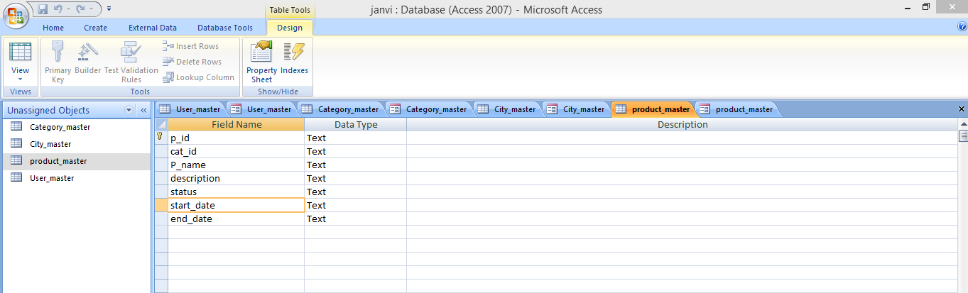

**Field of Value:**

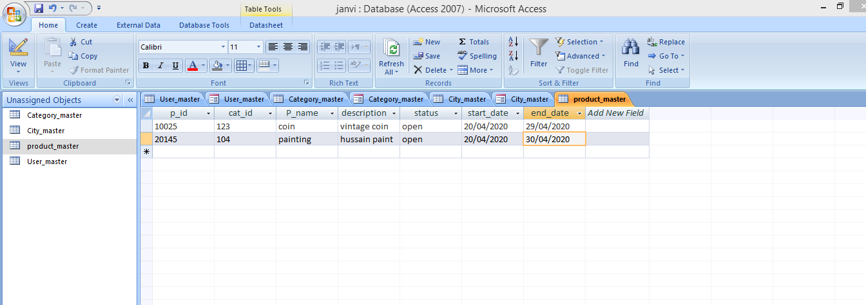

**Form:**

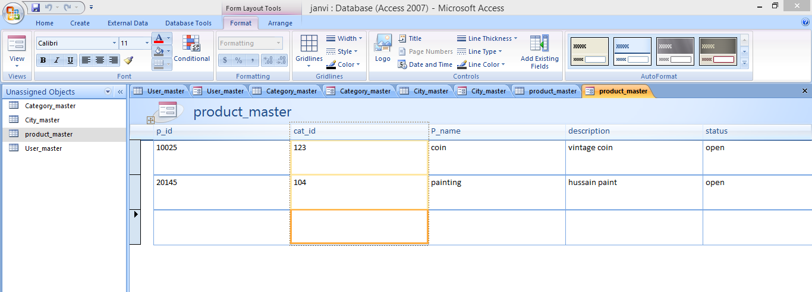

1. **Bid_Master:-**

**Table:**

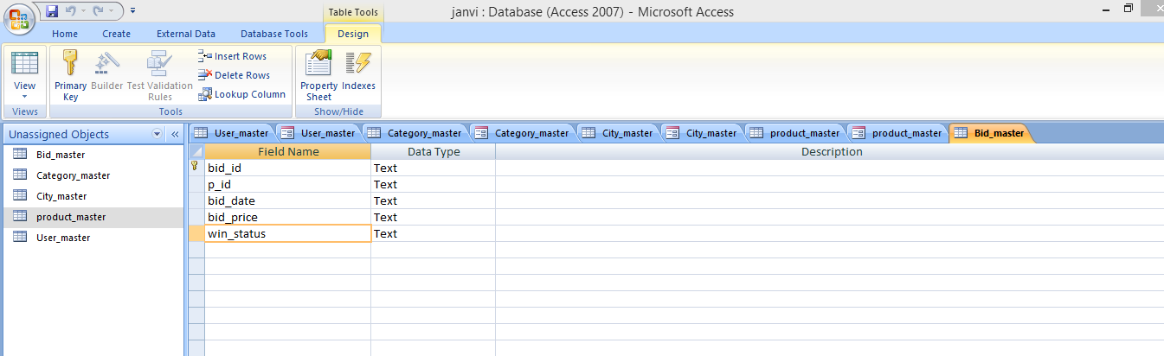

**Field of Value:**

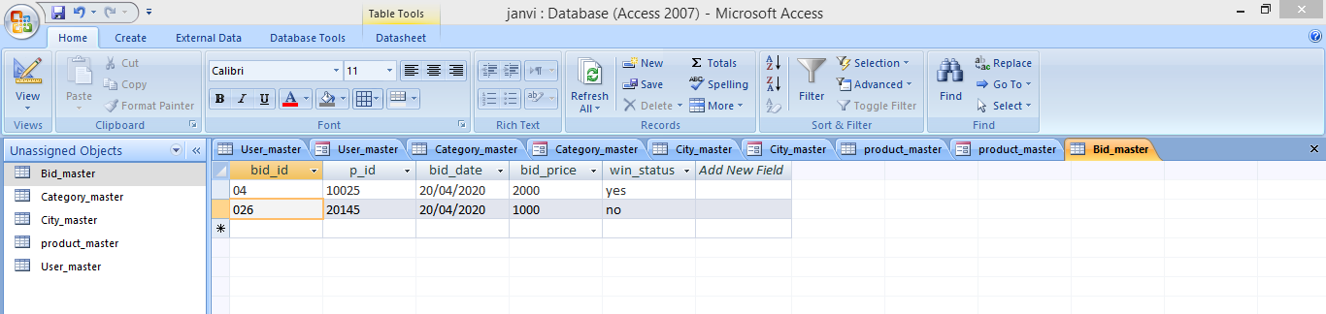

**Form:**

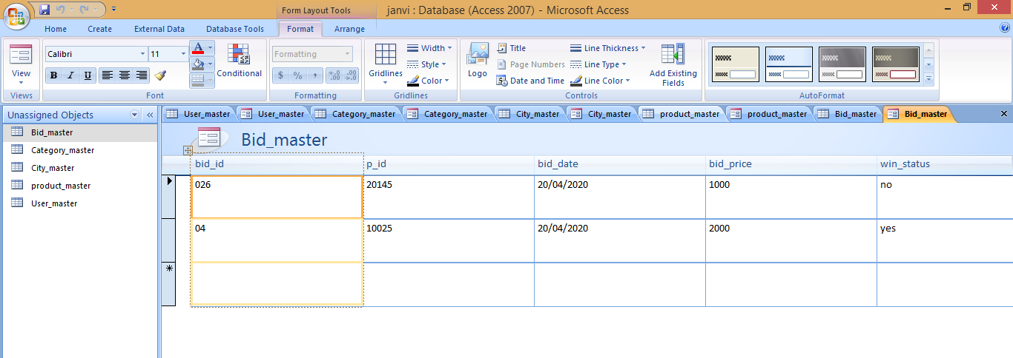

1. **Bidconfirm_Master:-**

**Table:**

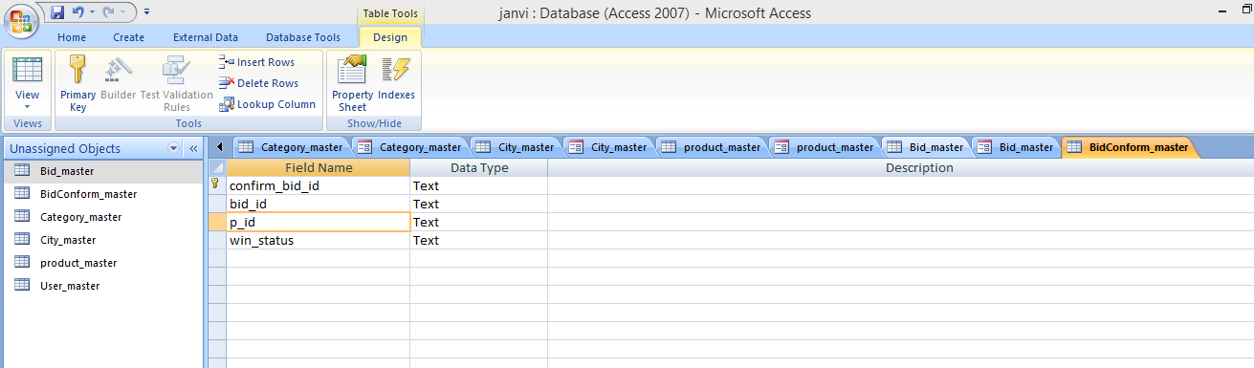

**Field of Value:**

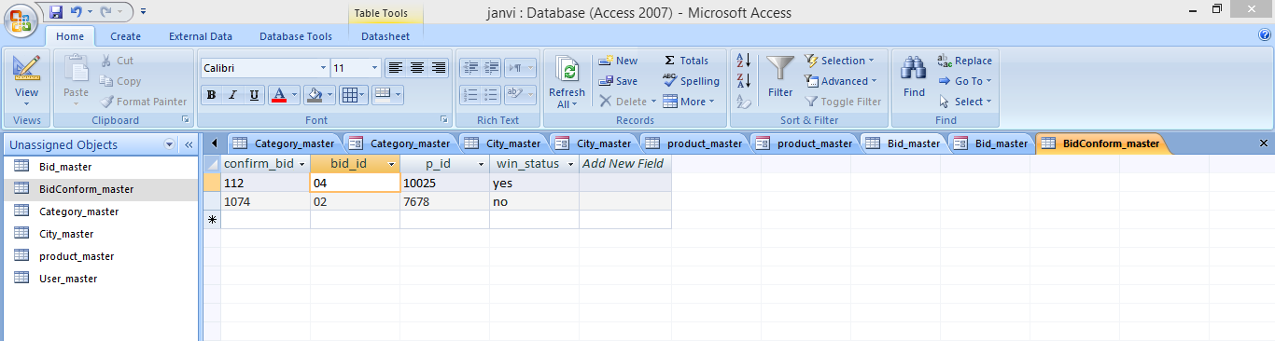

**Form:**

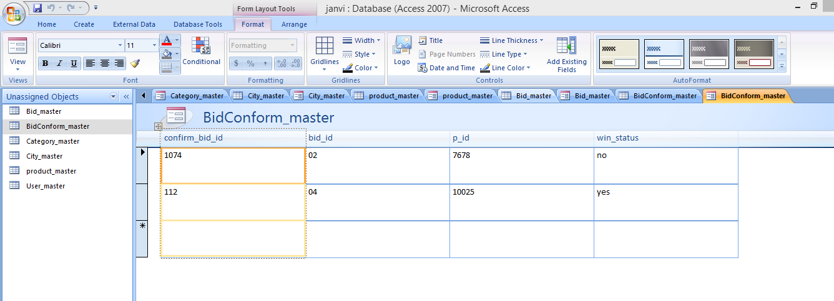

1. **Package_Master:-**

**Table:**

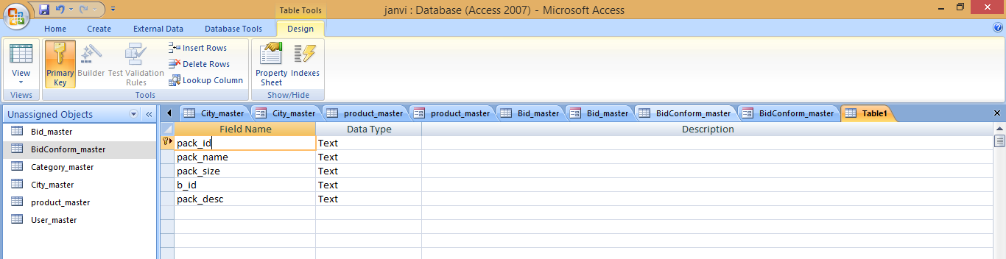

**Field of Value:**

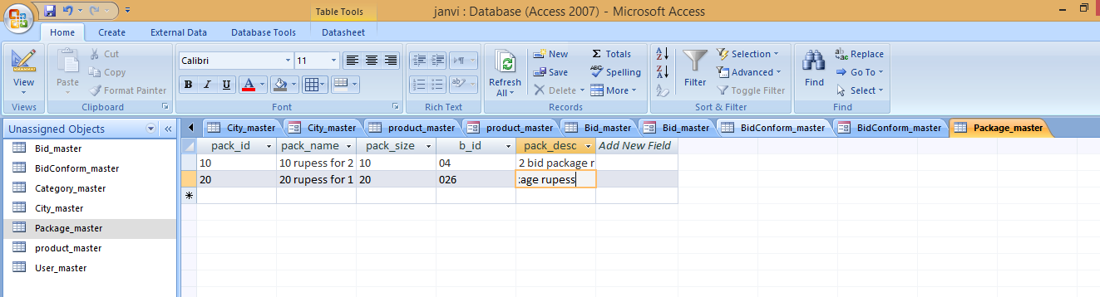

**Form:**

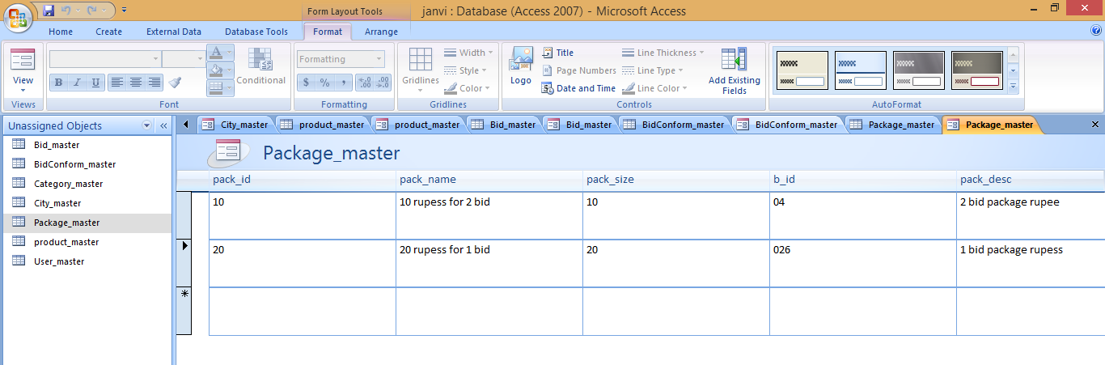

1. **Payment_Master:-**

**Table:**

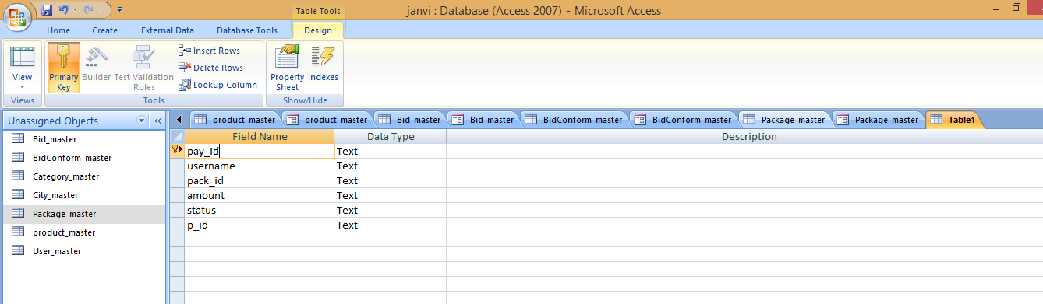

**Field of Value:**

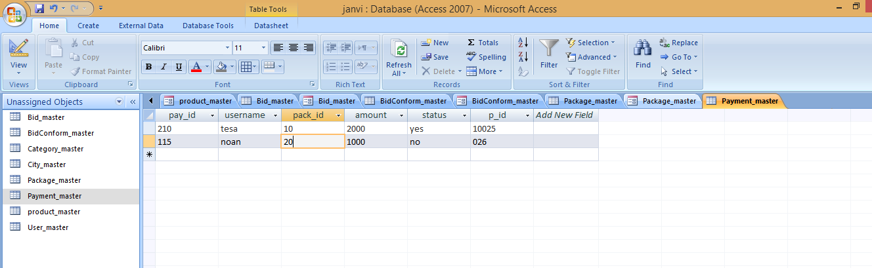

**Form:**

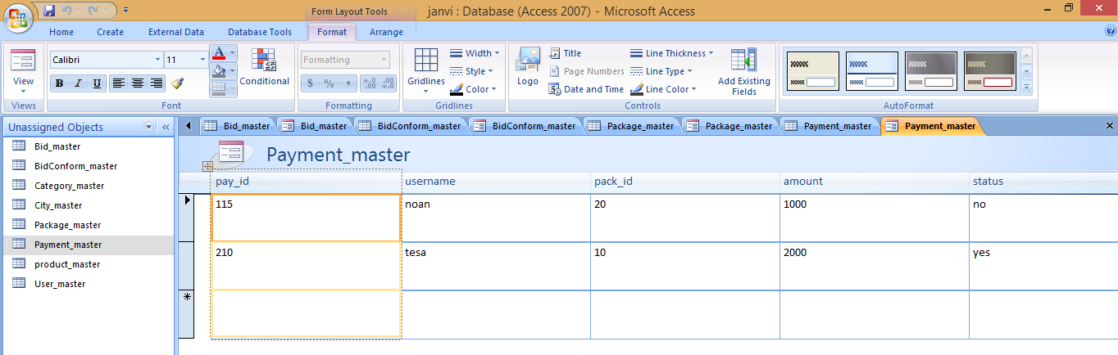

* 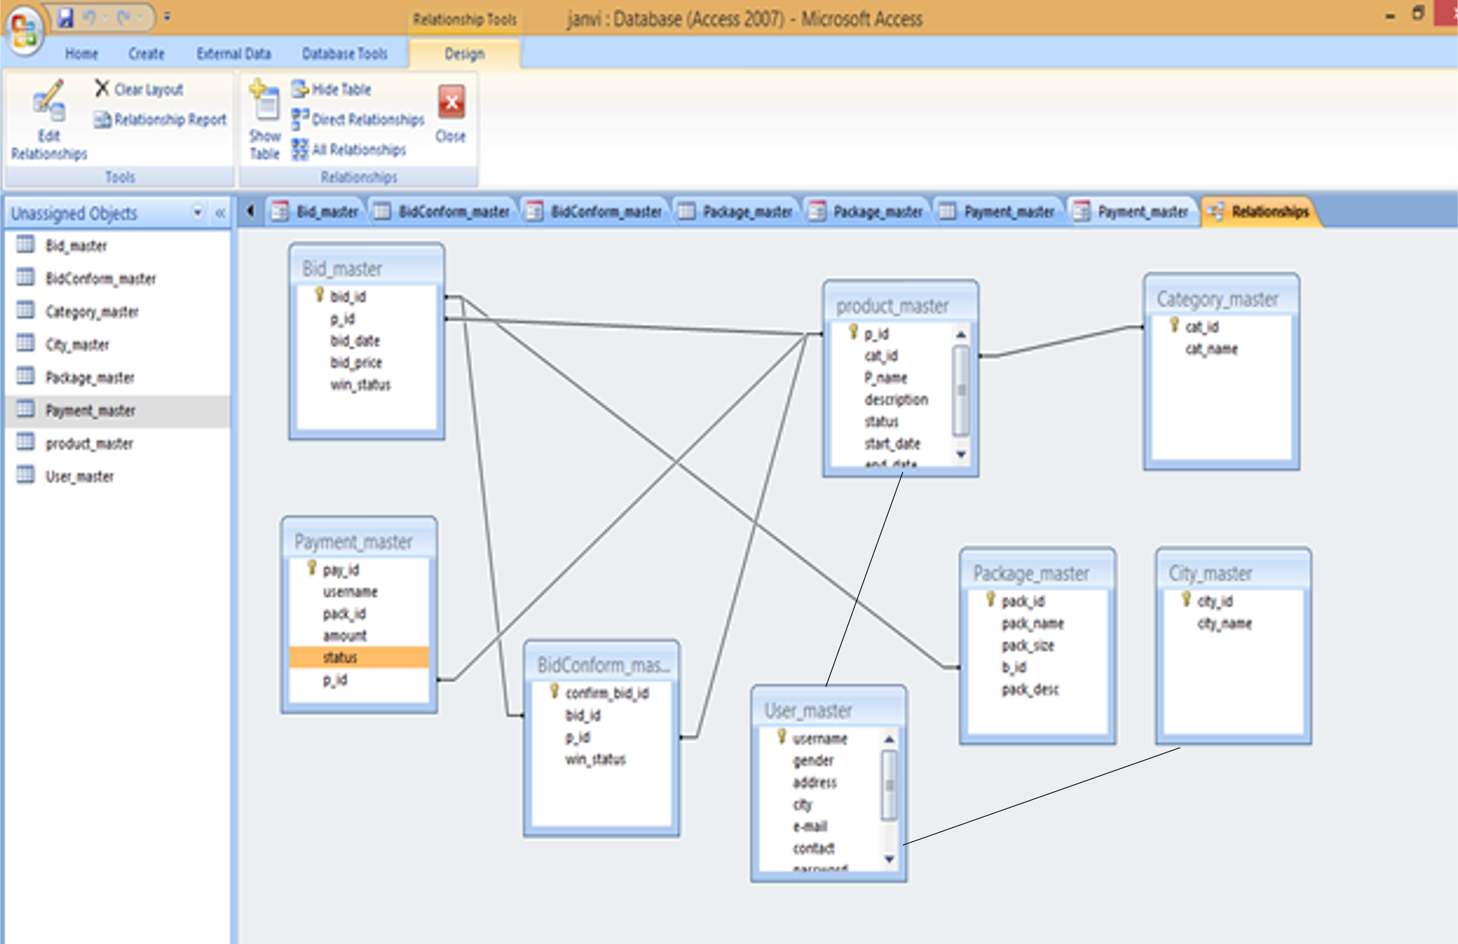**Back-end Relationship:**